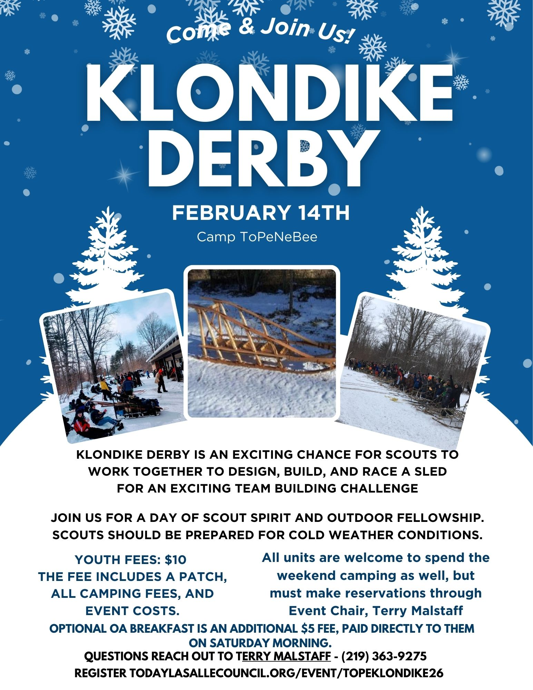

- GENERAL INFORMATION -

ANY QUESTIONS CALL/EMAIL
Klondike Derby Chair: Terry Malstaff 219.363.9275
Health Officer: Nicole Seitz
District Program Chair: Ann Ballinger 219.395.6442
District Executive: Dana Purcell, 219.561.5138

GENERAL INFORMATION:
Klondike Derby will be a day of scouting fun with a mixture of competitive spirit and outdoor fellowship. It is expected youth and adults will only bring scout items, behave, and conduct themselves as scouts should. Grievous event violations may lead to disqualification of individuals or even whole patrols.

Fees:
$10 per participating youth. Fee includes patch, all camp fees, and event costs. No Cost for Adult Leaders. Additional Patches are available for $3. Optional OA breakfast is an additional fee ($5), paid to them on Saturday morning.

Registration:
- Registration will be available on Council website.
- Register at the event on Friday, February 14 at the Training Center (see schedule). Please have exact amount or check.

Eligibility:
All Scouting America Troops, Sea Scout Ships, and Venturing Crews are welcome to attend and participate. Patrols will be maximum of (8) and minimum of (4) youth.

Health Forms:
Completed forms A & B will be reviewed at time of check in. Every Scout (youth and adult) must present their health forms during check-in, individually or with their unit.

Environment:
Please keep in mind that this is February in northern Indiana. It could be brutally cold or unseasonably warm. BE PREPARED. Proper clothing is a must and should be layered so the Scout can remove some layers if too hot or add layers if cold. Scout uniform is not required. This should be covered at Crew and Scouts BSA meetings if attending. This event will not be canceled because of cold weather. Bring plenty of clothing to change into to keep dry if necessary. A warming shelter will be available in case of emergency.

Food:
Units must provide their own food for the day and/or weekend. Optional Saturday OA breakfast is an additional fee ($5), paid to them on Saturday morning.

Announcements:
Health Officer is stationed at the Campmaster Cabin/Health Lodge
Please remind Scouts of:
-Buddy System
-Being mindful of Latrine sign –“Youth” or “Adult” occupying latrine.

Staffing:
Klondike event requires that all registered patrols provide a minimum of (1) adult volunteer to staff the event. Volunteer names will be taken down at time of check in. Volunteers will receive event identification and instruction packages on the morning of the event (see schedule).

Event Scoring:
Scoring will be by points 1-10. Score sheets will be provided

Camping:
The event will be across all Camp Topenebee. Units will be camping in campsites around Tope. You may request campsites in advance by contacting Terry Malstaff. Units will be assigned a campsite at check-in. It is winter camping so proper planning should be in place. This should be covered at Crew and Scouts BSA meetings if camping. A warming shelter will be available in case of emergency only.

Parking:
Parking will only be allowed in the main parking lot. Patrols may allow one (1) vehicle to their campsite to drop off their trailer. No overnight parking in campsites. Anything else must be taken back to camp on their sleds or carried.
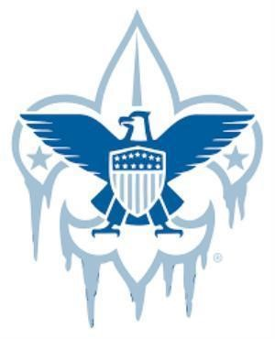
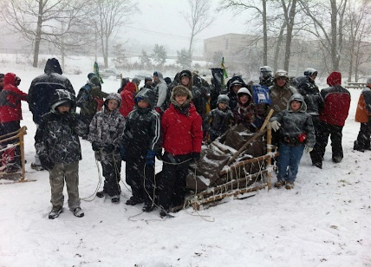
Sleds:
Offering 2 options for 2026 – Traditional and Modified. Traditional: It is highly encouraged for sleds to be made from all wood materials which display the scouts’ abilities to use natural products and lashing skills. No commercially built sleds. Make it however else the patrol wishes. 2 ft. wide X 6 ft. long – minimum. Modified: same parameter for size, any material. Each division will be judged separately per sled entry.

COURSE EVENTS:

Info:
We are not giving full details on each event to keep things a mystery. However, do not expect them all to be identical to previous years’ events. This year there will be (8) stations. Make sure to practice knots, first aid, fire building, orienteering, and other basic Scout skills.

GROUP EVENTS:

*Note: 2 Sled judgings & races (Traditional and Modified) will be run and separate prizes will be awarded.

Best Sled:
“Traditional” Sleds will be judged based on authenticity of natural material construction, lashing, functionality, and aesthetics. “Modified” Sleds will be judged on functionality and uniqueness. Each Patrol should have a patrol flag with Troop number on their sled. ALL SLEDS must make it through ALL event tasks to race.

Sled Race:
The grand finale, bragging rights for the year! Race your sleds to the finish line. Sleds are to be empty to reduce drag. *A 60 lb. sand tube will be placed on each sled for the race. At least 4 members of the patrol race with the sled. Those members of patrol and the sled must cross the finish line. The fastest sled wins!

HOW IT WILL WORK:

Patrols check in at the Training Center and have sleds inspected (see schedule). Patrols are given general instructions. The station staff will give to the patrol that station’s task, which they must solve and what to do when they finish. Upon completion or time up, the station staff will determine the patrol’s score and sends them to the next challenge. There will be an air gun start with patrols starting at different stations. All judging stations will retain score sheets. Klondike staff, with assistance from district program chair and/or district executive if present, will decide what to do for a tie breaker after all events are complete. This decision will be FINAL.

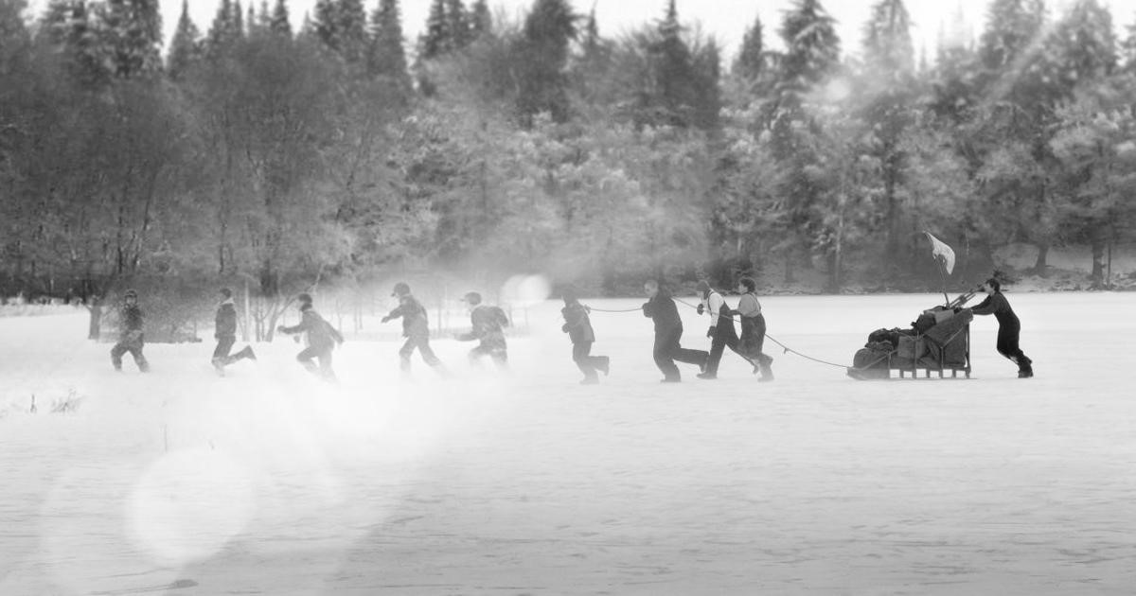

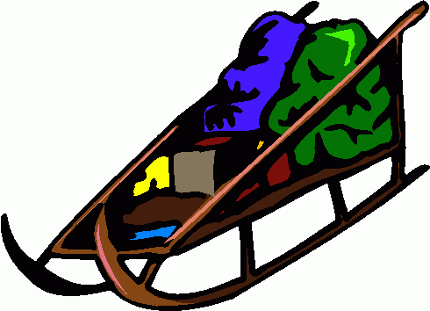
SLED EQUIPMENT LIST:
Patrol flag with troop number on it
Patrol roster
(3) Gallons water in container
Mess Kit or Pot with a lid
Watch
First Aid Kit (this kit will be used during the event; make sure you’re planning accordingly – some items needed include two sterile dressings, two compression triangular bandages, and material for splints)
Flint & steel, hot spark kit, or matches
Solid fuel to build a fire which should reach 2 feet high or so (natural material, birch bark, twigs, dryer lint, tinder, hatchet, etc.)
-No fatwood, no charcoal, no items with chemicals
-Flint and Steel preferred.
-Matches or lighters can be used but points can be deducted.
(2) Blankets (camp style) or Tarps
(3) Six to eight-foot poles for stretcher & travois.
50 ft of 3/8” Rope, 1/2” Rope, or Paracord (This will be used and cut up)
- 10 ft. X 10 ft. tarp (minimum size, can be larger)

PARTICIPANT EQUIPMENT LIST
Scout Handbook
Pencil / Pen and Paper
Scout Neckerchief (Each participant should have one)
Scouts BSA 10 Essentials for each participant
- Map and Compass
- Skin Protection
- Extra Clothing
- Flashlight
- First-Aid Kit
- Fire Starting items (Can be with patrols items)
- Pocketknife
- Trail Food
- Water Bottle (filled)
- Rain Gear

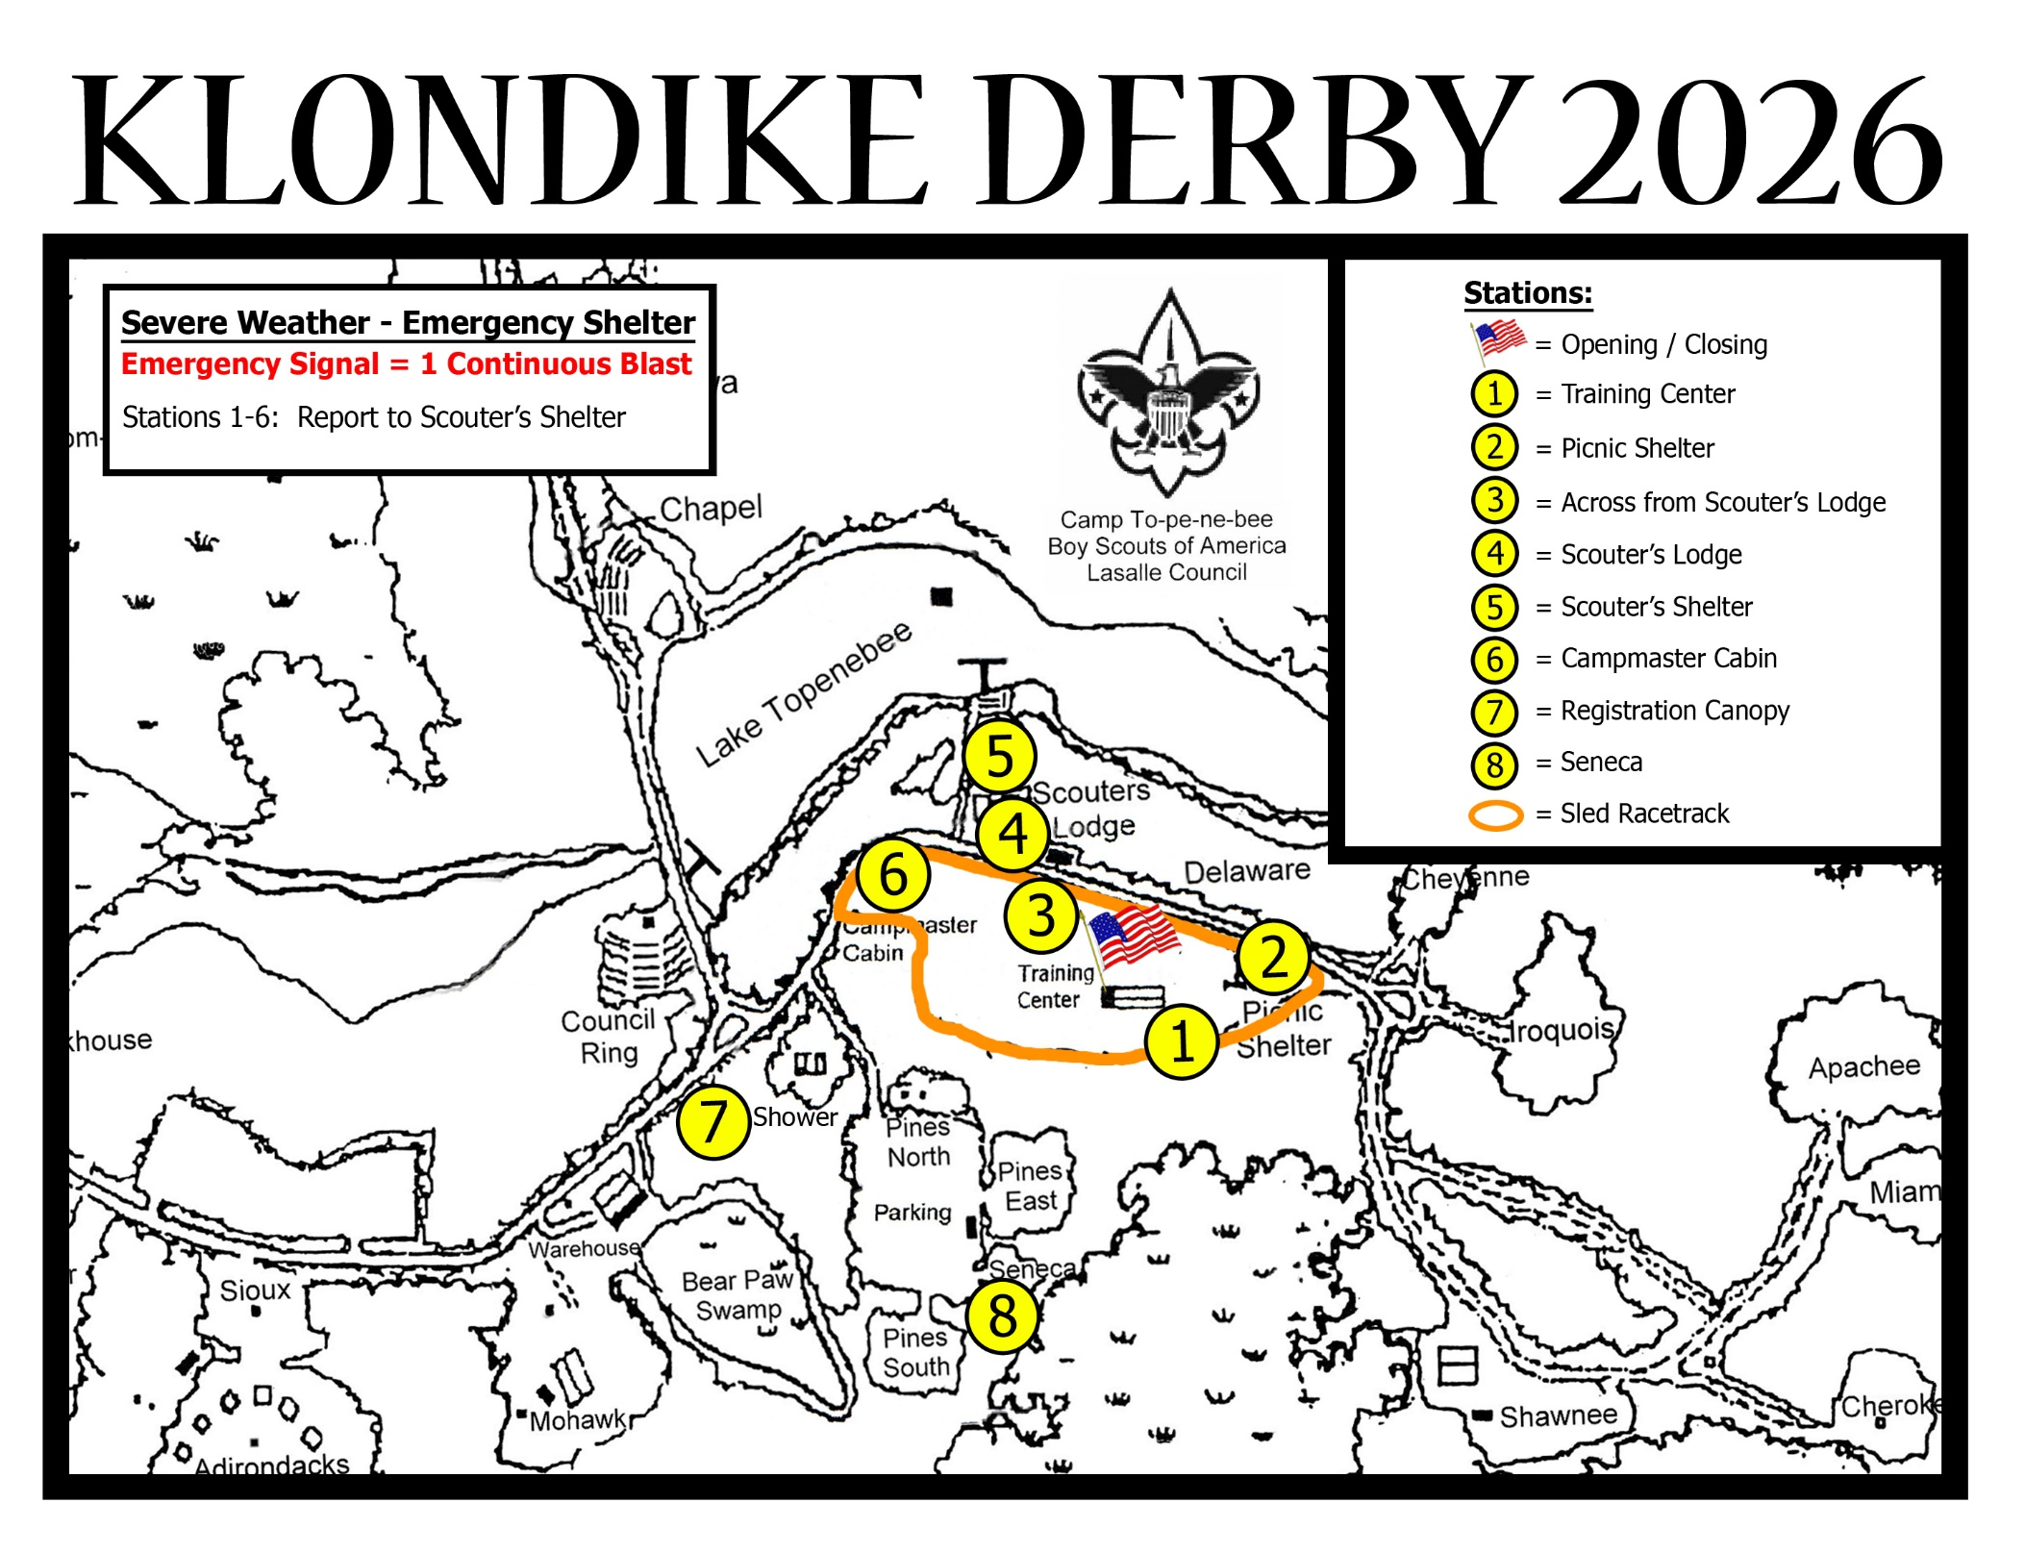

2026 Klondike Schedule
Friday
2:00 - 5:00PM Staff Report- Station Set up
5:00 - 8:00PM Check in/registration if camping Friday night
Saturday
7:00 - 8:00 AM Check in/registration if not camping Friday night
8:00 - 8:30 AM Opening Flags, Announcements, Sled Judging
8:30 - 9:00 AM Travel to Starting Stations
9:00 AM Shotgun Start
9:00 - 9:25 AM Station (Stations rotate for each sled team – see your team’s
schedule)
9:25 - 9:30 AM Travel Time
9:30 - 9:55 AM Station
9:55 - 10:00 AM Travel Time
10:00 - 10:25 AM Station
10:25 - 10:30 AM Travel Time
10:30 - 10:55 AM Station
10:55 - 11:05 AM Travel Time
11:05 - 11:30 AM Station
11:30 – 12:30PM Lunch (Units Provide)
12:30 - 12:35 PM Travel Time
12:35 - 1:00 PM Station
1:00 - 1:05 PM Travel Time
1:05 - 1:30 PM Station
1:30 – 1:35 PM Travel Time
1:35 – 2:00 PM Station
2:00 – 2:15 PM Travel Time to Sled Race at Training Center
2:15 – 3:00 PM Sled Races
3:15 – 4:15 PM AWARDS
(schedule subject to change)

Safe Food Handling Instructions for Campsites and Stations:

- All foods that require refrigeration must be refrigerated until leaving for camp
- All foods that require refrigeration must be transported in coolers on ice
- If possible, a non-mercury ambient air thermometer should be inside each cooler to ensure the temperature remains
- Enough ice should be obtained to ensure foods remain at 41F or below until they are used/served.
- Before beginning any food handling/preparation, a hand wash station should first be set-up (see the top of attachment 1) and all participating in food handling should wash hands thoroughly.
- While handling foods, be sure to use prevent cross-contamination by using separate cutting boards and utensils for raw and ready to eat foods and for different raw animal proteins.
- While handling foods, be sure to wash hands when needed and wear gloves or use utensils to prevent contamination from bare hand contact.
- Use a properly calibrated food thermometer to ensure that all foods reach the proper cooking temperature for the proper amount of time.
- Once the meal is complete, no foods should be kept as leftover. Please discard all remaining foods after all have eaten their fill.
- All food and refuse should be collected at the campsite/station in a proper disposal bag and container and transported to the dumpster at the front of the camp on a regular basis. Likewise, any grease or oil used and/or generated should be collected and sealed in an appropriate container and discarded in the dumpster at the front of the camp.
- After the meal, all utensils and equipment should be washed, rinsed, and sanitized in a three-tub temporary water wash station. Be sure to use water at 110-120 to wash and to switch out the water wash station water as needed when the water becomes soiled. The proper sanitizer concentration using bleach is approximately 1 capful of bleach per gallon of water, but can vary with the age of the bleach. Test strips should be used to test for proper sanitation concentration.
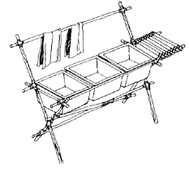

Klondike Derby 2026

Patrol Name | Troop Number
Leader/Volunteer Names:
Scout Names | Scout Names
1, | 5.
2, | 6.
3. | 7.
4. | 8.

Patrol Name | Troop Number
Leader/Volunteer Names:
Scout Names | Scout Names
1, | 5.
2, | 6.
3. | 7.
4. | 8.

Patrol Name | Troop Number
Leader/Volunteer Names:
Scout Names | Scout Names
1, | 5.
2, | 6.
3. | 7.
4. | 8.

TROOP # _________________ PATROL NAME _____________________________

HATCHET THROW

PERMISSION TO ENTER ________ 1 POINT

PATROL CHANT/YELL ________ 1 POINT

TEAMWORK ________ 1 POINT

PROPER LASHING ________ 4 POINTS

TARGET POINTS ________ 3 POINTS

TOTAL POINTS _______ / 10

JUDGE COMMENTS ON SLED PARTICIPATION
____________________________________________________________________________

____________________________________________________________________________
____________________________________________________________________________

TROOP # _________________ PATROL NAME _____________________________

FIRE BUILDING

PERMISSION TO ENTER ________ 1 POINT

PATROL CHANT/YELL ________ 1 POINT

TEAMWORK ________ 2 POINTS

PROPER FIRE ________ 2 POINTS

TIME PREPARED ________ 2 POINTS

COOKED FOOD ________ 2 POINTS

TOTAL POINTS _______ / 10

JUDGE COMMENTS ON SLED PARTICIPATION
____________________________________________________________________________

____________________________________________________________________________
____________________________________________________________________________

TROOP # _________________ PATROL NAME _____________________________

FIRST AID

PERMISSION TO ENTER ________ 1 POINT

PATROL CHANT/YELL ________ 1 POINT

TEAMWORK ________ 2 POINTS

KNOWLEDGE ________ 2 POINTS

PERFORMING TASKS CORRECTLY:
CALL 911 ________ 1 POINT
CHECK SURROUNDINGS ________ 1 POINT
TREAT WOUNDS CORRECTLY ________ 1 POINT
TRANSPORT VICTIM ________ 1 POINT

TOTAL POINTS _______ / 10

JUDGE COMMENTS ON SLED PARTICIPATION
____________________________________________________________________________

____________________________________________________________________________
____________________________________________________________________________

TROOP # _________________ PATROL NAME _____________________________

ALLIGATOR CROSSING – LASHING EVENT

PERMISSION TO ENTER ________ 1 POINT

PATROL CHANT/YELL ________ 1 POINT

TEAMWORK ________3 POINTS

PROPER LASHING ________ 3 POINTS

DISTANCE POINTS ________ 2 POINTS

TOTAL POINTS _______ / 10

JUDGE COMMENTS ON SLED PARTICIPATION
____________________________________________________________________________

____________________________________________________________________________
____________________________________________________________________________

TROOP # _________________ PATROL NAME _____________________________

2 MAN SAW

PERMISSION TO ENTER ________ 1 POINT

PATROL CHANT/YELL ________ 1 POINT

TEAMWORK _______ 3 POINTS
HOW DID THEY HANDLE SAW, WORKING IN TANDEM,
COMMUNICATION WHILE SAWING

TIME TO CUT LOG ________ 2 POINTS

QUALITY OF CUT ________ 1 POINT

EXTRA PROJECT ________ 2 POINTS

TOTAL POINTS _______ / 10

JUDGE COMMENTS ON SLED PARTICIPATION
____________________________________________________________________________

____________________________________________________________________________
____________________________________________________________________________

TROOP # _________________ PATROL NAME _____________________________

WOOD WORKING PROJECT

PERMISSION TO ENTER ________ 1 POINT

PATROL CHANT/YELL ________ 1 POINT

TEAMWORK _______ 3 POINTS
HOW DID THEY HANDLE SAW, WORKING IN TANDEM,
COMMUNICATION WHILE SAWING

SAFETY OF TOOLS ________ 3 POINTS

PROJECT BUILT ________ 2 POINTS

TOTAL POINTS _______ / 10

JUDGE COMMENTS ON SLED PARTICIPATION
____________________________________________________________________________

____________________________________________________________________________
____________________________________________________________________________

TROOP # _________________ PATROL NAME _____________________________

GOLD RUSH

PERMISSION TO ENTER ________ 1 POINT

PATROL CHANT/YELL ________ 1 POINT

TEAMWORK _______ 2 POINTS

COLLECT GOLD BRICK ________ 3 POINTS

GETS TO THE CHECKPOINT ________ 3 POINTS

TOTAL POINTS _______ / 10

JUDGE COMMENTS ON SLED PARTICIPATION
____________________________________________________________________________

____________________________________________________________________________
____________________________________________________________________________

TROOP # _________________ PATROL NAME _____________________________

TEAM BUILDING

PERMISSION TO ENTER ________ 1 POINT

PATROL CHANT/YELL ________ 1 POINT

TEAMWORK _______ 3 POINTS

KNOTS & LASHINGS ________ 3 POINTS

TIME TAKEN WITH SPORTSMANSHIP ________ 2 POINTS

TOTAL POINTS _______ / 10

JUDGE COMMENTS ON SLED PARTICIPATION
____________________________________________________________________________

____________________________________________________________________________
____________________________________________________________________________

