PIONEER TRAILS AND
ALGONQUIAN DISTRICTS
Proudly Present The
KLONDIKE DERBY
JANUARY 16-18, 2026

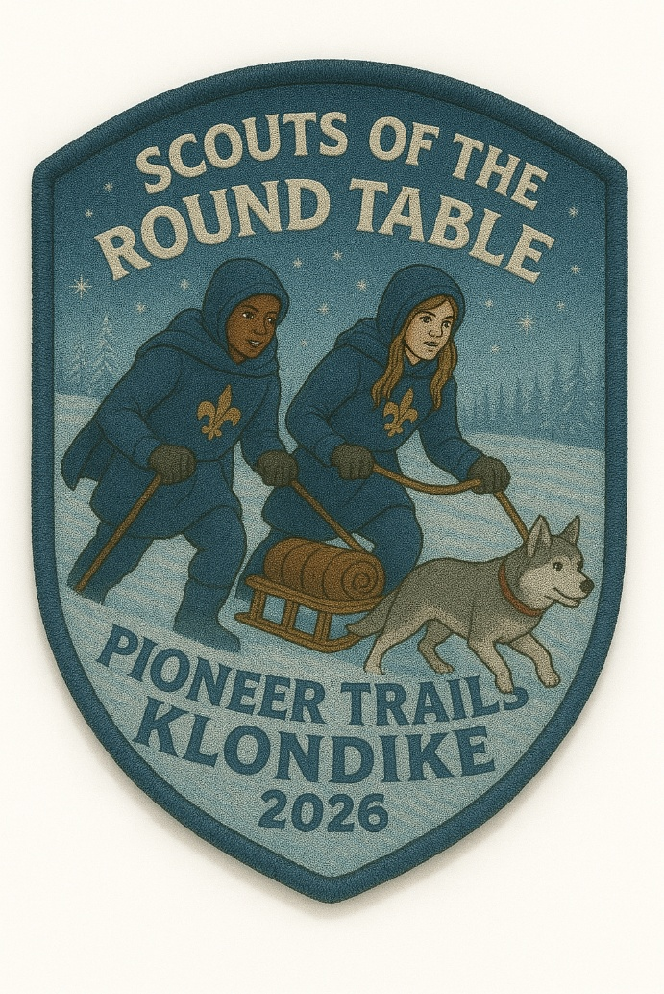

Wood Lake Scout Reservation, Camp Tamarack
10891 Withers Street, Jones MI 49061

ANY QUESTIONS CALL/EMAIL
Klondike Derby Chair: Creasy McKinzie, froggyxrs@gmail.com, 574.350.0480

GENERAL INFORMATION:
Klondike Derby will be a day of scouting fun with a mixture of competitive spirit and outdoor fellowship. It is expected youth and adults will only bring scout items, behave, and conduct themselves as scouts should. Grievous event violations may lead to disqualification of individuals or even whole patrols.

Fees:
Fees include patch, all camp fees, and event costs. Early bird pricing is $10 per participating youth, and adult leaders are $5. Early bird pricing ends at 11:59PM on January 1, 2026. Registrations after January 1, 2026, move to $15 per participating youth and $5 per adult leader.

Any unit wanting to camp a second night can add on Friday night (January 16th) camping for an additional $5.00 PER UNIT.

Registration:
Registration will be available at https://lasallecouncil.org/event/pt-klondike-derby/
Check In and Pre-Registration will open on Friday Jan. 16th from 5:30pm to 9:00pm for early check-in and Saturday morning for standard check-in on the Trading Post porch (see schedule). Exact amount or check please.
BONUS - Patrols registering ON or BEFORE January 1, 2026, will receive (5) extra Points.

Eligibility:
All Scouts BSA Troops and Crews are welcome to attend and participate. AOL’s may attend, camp, and participate if invited by a troop/crew. AOL’s are the responsibility of the host troop/crew and can participate only if mixed in with patrols. Patrols will be maximum of (8) and minimum of (4) youth. If a Unit that does not have enough youth to be a patrol, please contact the Klondike Chair to make arrangements so no youth gets left behind.

Health Forms:
Completed forms A & B will be reviewed at time of check-in. Only the SPL and a Leader are to bring the health forms of the unit to registration.

Environment:
It is January in northern Indiana. It could be brutally cold or unseasonably warm. BE PREPARED. Proper clothing is a must and should be layered so the Scout can remove some layers if too hot or add layers if cold. Scout uniform is not required. This should be covered at Crew and Scouts BSA meetings if attending. This event will not be canceled because of cold weather. Bring plenty of clothing to change into to keep dry if necessary. A warming shelter will be available in case of emergency.

Food:
Troops must provide their own food for the day and/or weekend.

Staffing:
Klondike event requires that all registered patrols provide a minimum of (1) adult volunteer to staff the event. Volunteer names will be taken down at time of check in. Volunteers will receive event identification and instruction packages on the morning of the event (see schedule).

Event Scoring:
Scoring will be by points. Patrols will receive tiered levels of points on the course for challenge completion, teamwork, and scout spirit. The top (3) patrols with the most points at the end of the event will receive prizes.

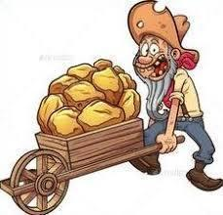
Prizes:
1st Place - $75 Scout shop card & Traveling Trophy
2nd Place - $50 Scout shop card
3rd Place - $25 Scout shop card

Camping:
The event will be across all WLSR. Units will be camping in campsites around Wood Lake. You will be assigned a campsite at check-in. It is winter camping so proper planning should be in place. This should be covered at Crew and Scouts BSA meetings if camping. Some general information on winter camping: https://troopleader.scouting.org/program-features/winter-camping/plans-ideas/

A warming shelter will be available in case of emergency only. (Rotary Lodge)

Water at camp will be turned off for winter! The shower house restrooms are closed. The only available source for water are the two (2) winter hydrants at camp. Winter hydrants are pressure systems, do not pump the handle. Gently, pull the handle up for water. Gently, lower handle to shut water off. To keep units from freezing, you must drain 2 gallons of water each time used. Fill your water jug and use water from the jug. When the jug is empty, take it to the hydrant and fill. Do not use hydrants for personal hygiene or for water needs less than 2 gallons.

Parking:
Parking will only be allowed in the main parking lot. Patrols may allow one (1) vehicle to their campsite to drop off their trailer. No overnight parking in campsites. Anything else must be taken back to camp on their sleds or carried.

Fires:
The camp has a no ground fire policy. If you have above ground fire pits, please bring them as you will be sharing campsites with other units. Do NOT bring firewood to camp. Any wood down on the ground or in the camp wood stack in the parking lot is yours to use.

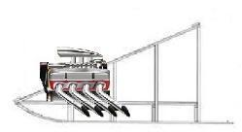
Sleds:
It is highly encouraged for sleds to be made from all wood materials which display the scouts’ abilities to use natural products and lashing skills. No commercially built sleds. These are the only rules this year. Make it however else the patrol wishes.

COURSE EVENTS:

Info:
We are not giving full details on each event to keep things a mystery. However, do not expect them all to be identical to previous years’ events. Stations will be based on practical skills needed in scenario-based settings. Make sure to practice knots, first aid, fire building, orienteering, and other basic Scout skills.

OPTIONAL GROUP EVENTS:

Best Sled:
Sleds will be judged based on authenticity of natural material construction, lashing, functionality, and aesthetics. Each Patrol having a patrol flag with Troop number on their sled will receive a bonus point. The best sled will earn an award!

Sled Race:
The grand finale, bragging rights for the year! Race your sleds to the finish line. Sleds are to be empty to reduce drag. Each member of patrol must participate unless medically ineligible. All members of patrol and the sled must cross the finish line. The fastest sled will earn an award!

HOW IT WILL WORK:

Patrols check in at the starting line and have sleds inspected (see schedule). Patrols are given general instructions. The claim holder at each challenge awards Points to the patrols. The claim holder will explain to the patrol the problems which they must resolve and what to do when they finish. Upon completion or time up, the claim holder awards the patrol the Points they earned and sends them to the next challenge. There will be a shotgun start with patrols heading to different stations. The Point awarding decision of the claim holder is FINAL.

Patrols must check in at HQ upon completion of the course. The patrol will turn in their Points for counting. The patrol will be given their Points total. Multiple HQ check ins are NOT allowed. Patrols not reporting into HQ risk not having their efforts recorded. HQ will stop taking check ins at the beginning of service project time (see schedule).

Klondike chairman(s), with assistance from district program chair and/or district executive if present, will decide what to do for a tie breaker after all events are complete. This decision will be FINAL.

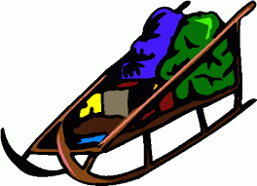
SLED EQUIPMENT LIST:
Patrol flag with troop number on it
Patrol roster
Watch
Pocketknife
(3) Gallons water in container
Flint, steel, hot spark kit, or matches
Scout Handbook
Trash bag
(2) Blankets (camp style)
(2) Six to eight-foot poles for stretcher & travois.
(1) Four to six-foot poles for travois.
(8) Six-foot lengths of rope (strong ¼”)
Several rope pieces good for knot tying
Solid fuel to build a fire which should reach 2 feet high or so (natural material, birch bark, twigs, etc.)
First Aid kit (two sterile dressings, two compression triangular bandages, and material for splints)
Fifty (50) feet of ½” diameter rope
(1) 10ft x 10ft tarp (minimum size, can be larger)
Sturdy waterproof container for Points marked with patrol name and troop number. Walmart type plastic bags are not recommended. The event will not replace lost Points.
- Dutch Oven
A complete extra set of warm dry clothes and socks for each patrol member *
Rain gear for each patrol member *
*These items can be carried in patrol members backpacks but must be on sled for certain events.

PERSONAL EQUIPMENT:
Nothing required but recommendations would be weather-related items, water bottle, etc.

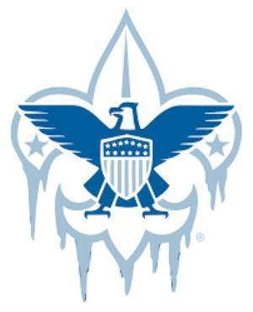
Schedule

Friday Night - Optional
Registration / Campsite Setup | 6:00 PM | 10:00 PM
Saturday
Registration / Campsite Setup | 7:00 AM | 8:00 AM
Leader Meeting | 8:00 AM | 8:30 AM
Flags | 8:30 AM | 8:45 AM
Sled Photo Op | 8:45 AM | 9:00 AM
Klondike Events | 9:00 AM | 11:00 AM
Lunch (Provided by Units) / Campsite Setup and Inspection | 11:00 AM | 1:00 PM
Klondike Events | 1:00 PM | 3:00 PM
Sled Race - Optional | 3:00 PM | 4:00 PM
Service Project | 4:00 PM | 5:00 PM
Awards | 5:00 PM | 5:30 PM
Dinner (Provided by Units) | 5:30 PM | 10:00 PM
Lights Out | 10:00 PM
Sunday
Breakfast (Provided by Units) | 8:00 AM
Tear Down Camp | 9:00 AM
Church Service | 10:00 AM
Checkout | 12:00 PM

(Schedule subject to change)

